

GUIDING DOCUMENT FOR 2.0 PROJECT
Request for Proposal (RFP) for the implementation of municipal Energy Efficiency and Demand Side Management (EEDSM) Programme

Period: 2027/28 Financial Year (FY), 2028/29 FY and 2029/30 FY

PART A: EEDSM 1.0 PROJECTS

PART B: EEDSM 2.0 PROJECTS

Date Issued: 15 August 2026
RFP Document number: 01

Table of Contents
Disclaimer 3
1. Purpose of the Request for Proposal (RfP) 4
2. Introduction & Context 4
2.1 Reasons for undertaking EEDSM measures 5
2.2 Municipal EEDSM Programme Scope 5
2.2.1 Part A: EEDSM 1.0 Projects 5
2.2.1.1 SCOPE FOR THE MUNICIPAL EEDSM 1.0 PROJECT PROPOSAL 6
2.2.2 Part B: EEDSM 2.0 Projects: Energy Savings Performance Contract 7
2.2.2.1 Scope for municipal EEDSM 2.0 Projects 8
2.2.2.2 Municipal EEDSM 2.0 Project Proposal Templates 9
3. 2026 EEDSM RfP Submission Procedure 9
4. Selection Criteria for 2026 EEDSM 1.0 Project Proposals 10
5. Selection Criteria for 2026 EEDSM 2.0 Project Proposals 10
6. Sector Advancement and Skills Development 11
6.1 Formalization and Accreditation of ESCOs 11
6.2 Creation of a Local M&V Profession 12
6.3 Local Manufacturing and Industrial Policy 12
6.4 Small, Medium and Micro Enterprise (SMME) 12
6.5. Gender Mainstreaming 12
7. How to Respond? 13
8. Contact Details 13
9. Timeframe 13

Disclaimer
The Department of Electricity and Energy (DEE) has prepared this information document to request municipalities to submit Proposals for funding consideration of the Energy Efficiency and Demand Side Management (EEDSM) component in the Integrated National Electrification Programme (INEP) grant for the 2027/28, 2028/29 and/or 2029/30 financial years. The objective of the EEDSM component of the INEP grant is to provide subsidies to municipalities to accelerate the implementation of EEDSM measures and reduce electricity demand in municipal buildings and infrastructure.

The Request for Proposals for the next three (3) financial years (2027/28, 2028/29 and/or 2029/30) has been structured into two parts: Part A: EEDSM 1.0, structured to support grant-funded energy efficiency retrofits without expectation for the municipality to leverage private sector finance; and Part B: EEDSM 2.0 structured to leverage private sector finance, develop and implement an Energy Savings Performance Contracting (ESPC) model with the support of an Energy Services Company (ESCo) and/or Original Equipment Manufacturing (OEM) company(ies) for the required energy efficient technologies.

The proposals under the EEDSM 2.0 should be aligned to current regulatory framework, particularly Treasury Regulation 16 and the Municipal Public-Private Partnership (PPP) Regulations promulgated under the Municipal Finance Management Act (MFMA) Act 56 of 2003.

Municipalities responding to this RFP should note that submitted proposals shall be non-binding to the DEE, its staff, and its advisors or any other organization providing assistance to the DEE. No re-imbursement of costs or expenses of any type whatsoever will be paid to respondents or any other persons, or entities expressing interest in the purposes of submitting the Proposals.

No municipality shall have a claim against the DEE, its staff or its advisors, or any other organization providing assistance to the DEE, arising out of any matter relating to this 2026 EEDSM RfP document.

Purpose of the Request for Proposal (RfP)
This 2026 EEDSM RfP is to request municipalities to submit EEDSM Project proposals either Part A: EEDSM 1.0 or Part B: EEDSM 2.0 for funding consideration under the EEDSM component of the INEP grant for the 2027/28, 2028/2029 and 2029/30 financial years.

The DEE will evaluate these proposals based on a pre-determined criterion which include amongst others energy savings potential, investment costs, quick pay-back periods, opportunity to create local jobs, and leveraging private finance.

Introduction & Context
The Division of Revenue Act is the primary legislative mechanism through which national revenue is shared among the three spheres of government in South Africa. Section 214(1) of the Constitution provides that local government, and each province are entitled to "an equitable share of revenue raised nationally". The INEP conditional grant is managed by DEE to achieve universal access to electricity, reduce household electrification backlogs; and increase energy efficiency and reduced demand for electricity

Energy efficiency is widely recognized as the most fundamental short-run imperative for rapid, ambitious and cost-effective climate change mitigation. As a matter of fact, improved efficiency is the most cost-effective, least-polluting and readily available energy resource. More than half of the electricity-sector related carbon emissions reduction target in the coming twenty years could be achieved through energy efficiency.

Energy Efficiency can enhance the competitiveness of economies while helping to alleviate energy poverty as energy becomes more available. Energy productivity gains will lower the cost for the economy as a whole, enhance the supply security and reduce the need to develop new sources of energy supply to serve those without access to modern energy services for health and education enhancement. Accelerated energy efficiency can also create attractive green jobs and businesses.

As a commitment to this process, the DEE is in the process of reviewing the post-2015 National Energy Efficiency Strategy (NEES), setting energy efficiency targets for the period of 2026 – 2035. Key energy efficiency measures that the reviewed NEES proposes to be accelerated include wider rollout of Energy Performance Certificates (EPCs), and a gradual shift from the energy efficiency grant towards an ESPC model and market-based efficiency obligations.

The Proposals for Part A: EEDSM 1.0 or Part B: EEDSM 2.0 from the municipalities through this 2026 EEDSM RfP should support the achievements of the reviewed NEES document, and include interventions with good socio-economic indicators, and higher private cofinancing.

2.1 Reasons for undertaking EEDSM measures
The municipal EEDSM programme is based on decisive factors such as rising energy prices, increase in population, increased energy consumption, increased greenhouse gas (GHG) emissions and increased demand for water supply that affect effective municipal administration.

It is envisaged that through this municipal EEDSM programme, municipalities might reduce their electricity bills by optimizing energy use, improving delivery of services, reducing GHG emission, undertaking retrofitting of existing facilities such as street lighting, traffic signals, municipal buildings, water pumping and waste water treatment plants.

2.2 Municipal EEDSM Programme Scope

2.2.1 Part A: EEDSM 1.0 Projects
The recommended municipal EEDSM 1.0 projects for Part A should only focus on grant-funded energy efficiency retrofits that only rely entirely on the INEP grant without any leveraging of private sector finance. This model covers 100% of project costs focusing on the following:
- Inventory and system mapping of the buildings and infrastructure targeted for the energy efficiency improvements within the municipality to cover size, geographic location, type of technology, etc.
- Determination of energy consumption baseline and financial details on the investment required, including materials and potential service providers, expected savings, and payback period for each municipal infrastructure to be considered, namely public lighting, buildings, or water services.
- Energy efficiency retrofits, and system optimization of major energy consuming equipment in public lighting, buildings, and water services infrastructure.
- Technical, operational and financial risks analysis for the respective projects, including the mechanisms that need to be put in place to manage and control risks.
- Energy Efficiency Awareness and Communications.
- Skills development for local energy audits, technicians and electrifications.
- Preparation and submission of monthly, quarterly and annual reporting on implementation progress, expenditure and achieved energy savings of the implemented projects.

2.2.1.1 SCOPE FOR THE MUNICIPAL EEDSM 1.0 PROJECT PROPOSAL
The scope for the municipal EEDSM 1.0 Project Proposal should be for the 2027/28 to 2029/30 and cover baseline energy audits, Light-Emitting Diode (LED) street and high-mast lighting retrofits, municipal building HVAC and LED lighting retrofits with possible alternative clean energy technologies, water motors and pumps retrofits and optimization; project management; skills development, and energy efficiency awareness campaigns.

Interested municipalities are required to include in their EEDSM 1.0 Project Proposal, at least the following:
- Description of buildings and/or infrastructure targeted for the EEDSM measures
The description of buildings and/or infrastructure should include the type of building and/or infrastructure indicating the facility operational use, electricity consumption pattern and operating hours.

- Energy consumption baselines and steps used to determine baseline for the targeted buildings and/or infrastructure
The energy consumption baselines should be informed by detailed energy audits covering methodology used for data collection, measurements and analysis of historical and current electricity consumption, and detailed energy savings calculations for suggested EEDSM projects.

- Potential EEDSM projects with list of energy savings potential measures
Municipalities should include in the Proposals the findings of the energy audit that have been carried out at the targeted buildings and/or infrastructure measures. This should include selected technology options, and measures that have the best technical and economic potential with priorities for 2027/28, 2028/29 and/or 2029/30 financial years.

2.2.1.2 Municipal EEDSM 1.0 Project Templates
Municipalities are requested to submit EEDSM 1.0 Project Proposal illustrating measures for 2027/28, 2028/29 and/or 2029/30 using the summary table (Annexure A); EEDSM 1.0 Project Narrative (Annexure B) summarizing the list of projects targeted; and a Year 1 (2027/28) EEDSM 1.0 Project Work Plan (Annexure C).

2.2.1.3 Who should respond
All municipalities, not Consultants, should respond to this EEDSM 1.0 Request for Proposal. No proposals will be considered from Service Providers/Consultants irrespective of whether they have letter of support from a municipality.

2.2.2 Part B: EEDSM 2.0 Projects: Energy Savings Performance Contract
The scope for municipal EEDSM 2.0 is for municipalities that seek to use the grant-allocation as a credit enhancement and risk mitigation instrument to attract private capital into an Energy Savings Performance Contract. The municipal EEDSM 2.0 initiatives shall have the grant complemented by additional finance from an Energy Services Company (ESCo) using a minimum cofinancing ratio of 1:5, that is, R 1 million grant leveraging R 5 million private finance. The municipality and the ESCo shall share the monetary savings based on achieved energy savings (kWh) with a financial split (as per the off-take agreement/Service Level Agreement) based on a Shared Savings Model over a longer period (in most cases more than 3 years).

2.2.2.1 Scope for municipal EEDSM 2.0 Projects
Municipalities interested in participating in EEDSM 2.0 are required to provide a proposal that should indicate and confirm the structure of the ESCo Energy Savings Performance Contract as illustrated in Figure 1.

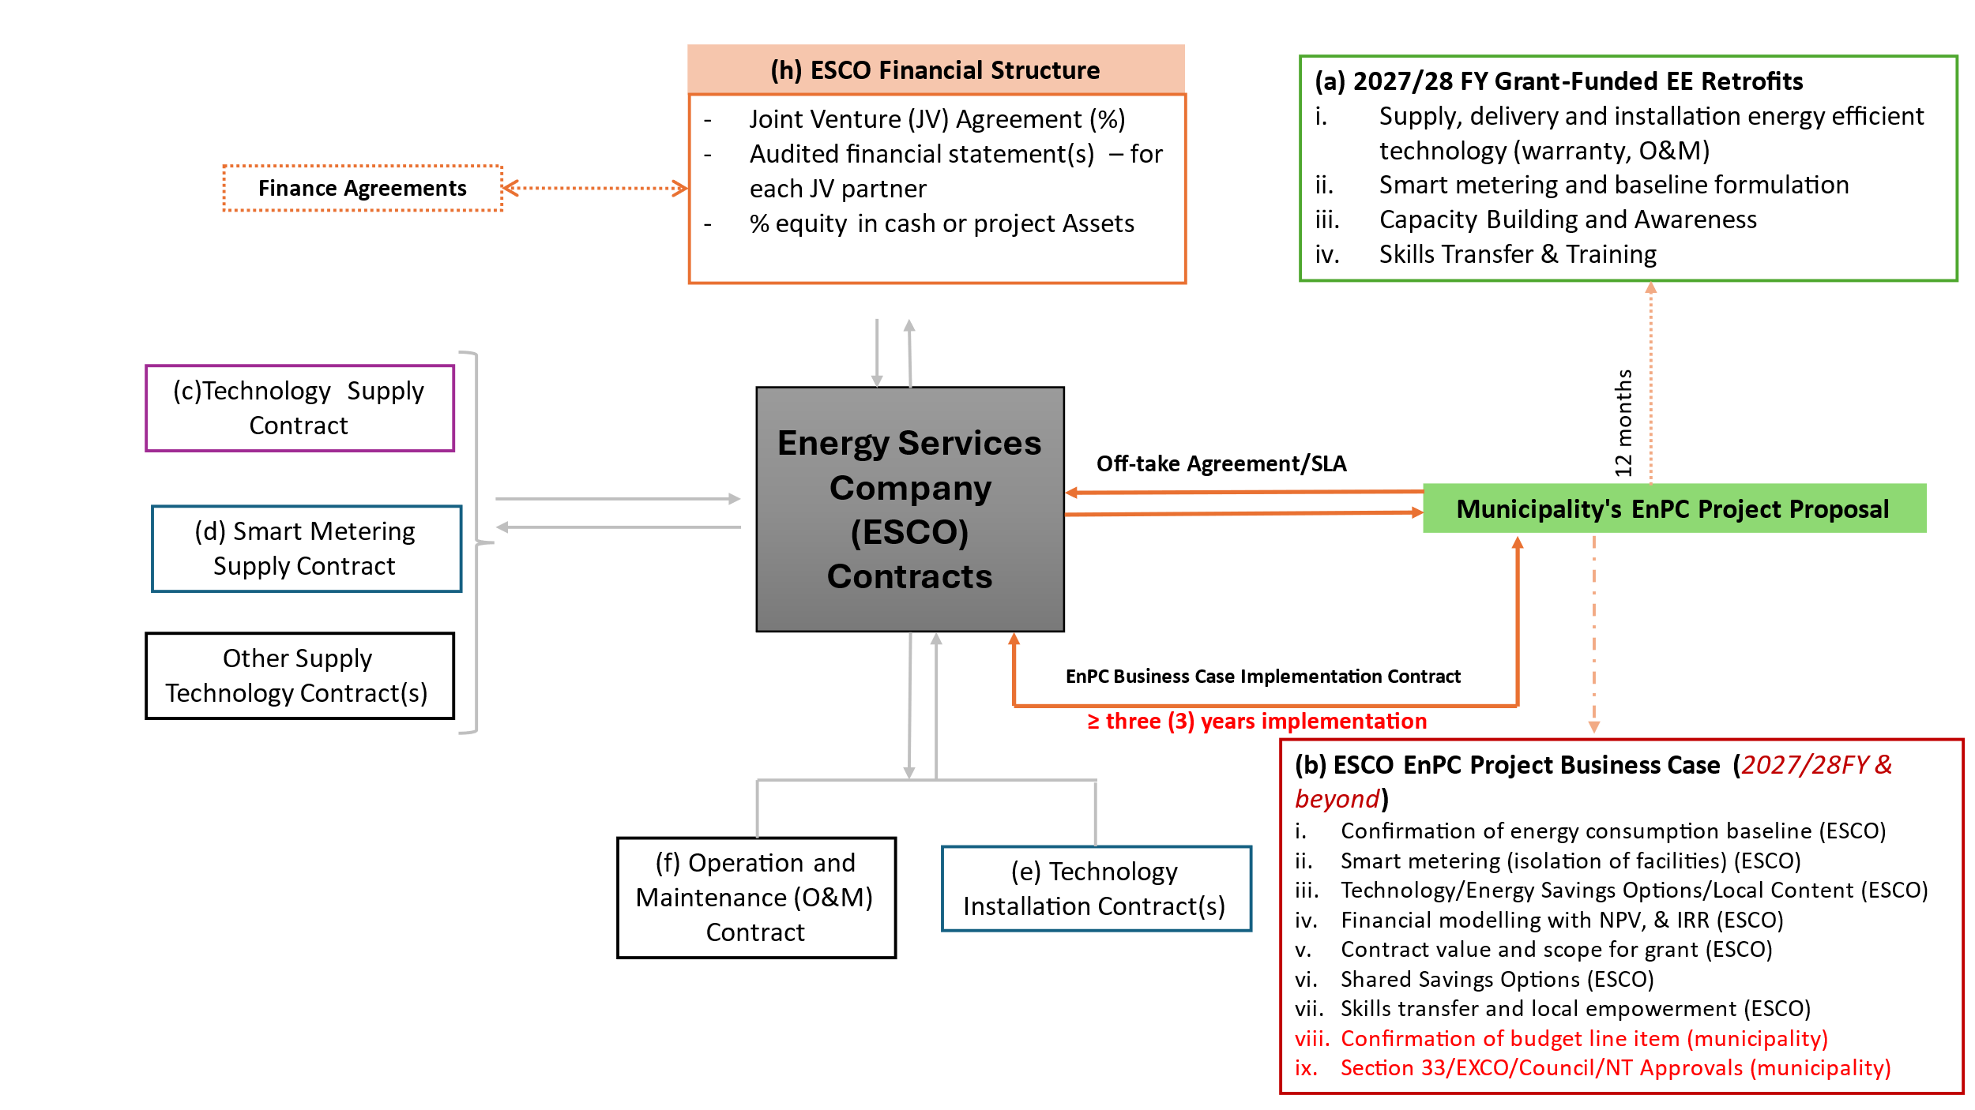
Figure 1: EEDSM 2.0: ESCo Energy Savings Performance Contract with a Municipality

As per figure 1, municipality’s proposal for the EEDSM 2.0 should be submitted as per Annexure D template covering at least the following:
- Description of the buildings and/or infrastructure targeted to be included in the EEDSM 2.0 project.
- Scope of the grant-funded energy efficiency retrofits that should be completed during 2027/28 financial year, in line with the conditions of the Division of Revenue Act.
- A business case or concept for the introduction of the ESCo Energy Savings Performance Contract with confirmed energy consumption baseline, required smart metering, technology options and energy savings, financial modelling with a Net Present Value (NPV) and Internal Rate of Return (IRR), and skills transfer.
- Confirmation of technology supplier agreements, smart metering supply contracts, and other required technologies/equipment.
- Project implementation structure highlighting operation and maintenance solution, installation contracts.
- Financial structure indicating the possible contribution from private sector (i.e. ESCo, financial institution(s), etc).
- Requirements for skills transfer and local empowerment as part of the implementation of the grant-funded energy efficiency retrofits and ESCo Energy Savings Performance Contract.

2.2.2.2 Municipal EEDSM 2.0 Project Proposal Templates
Municipalities are requested to submit EEDSM 2.0 Project Proposal illustrating measures for 2027/28, 2028/29 and/or 2029/30 using Annexure D template; EEDSM 2.0 Project Activity Plan using Annexure E template.

2.2.2.3 Who should respond
All municipalities, not Consultants, should respond to this EEDSM 2.0 Request for Proposal. No proposals will be considered from Service Providers/Consultants irrespective of whether they have letter of support from a municipality.

2026 EEDSM RfP Submission Procedure
In responding to this Request for Proposal, municipalities are expected either to submit EEDSM 1.0 Project Proposal using templates Annexure A, Annexure B and Annexure C, while Annexure D and Annexure E should be used by municipalities applying for EEDSM 2.0. The EEDSM 1.0 or EEDSM 2.0 Project Proposals should be signed by the Accounting Officer (Municipal Manager) or any person duly authorized thereto.

The language for submission of the document should be English. Cost incurred in compiling and submitting the Proposal shall be borne by the Municipality and shall not be claimed from the Department.

Selection Criteria for 2026 EEDSM 1.0 Project Proposals

Table 1: EEDSM 1.0 Project Proposal Criteria

Selection Criteria for 2026 EEDSM 2.0 Project Proposals
The selection of municipal EEDSM 2.0 Project Proposal for the introduction of an ESCo Energy Savings Performance Contract shall comply with municipal supply chain management rules, technical baseline precision, and clear financial/guarantee structures. In the submission of the municipal EEDSM 2.0 proposal, municipality’s proposal pack should cover administrative compliance, technical and performance aspects, and financial and commercial structure as per Table 2 below.
Table 2: EEDSM 2.0 Project Proposal Criteria

Sector Advancement and Skills Development
The municipality should illustrate in their proposal how the EEDSM 2.0 will advance the South African energy efficiency sector in at least the following five (5) measurable ways:

6.1 Formalization and Accreditation of ESCOs
In support of the municipal EEDSM 2.0, the Department will develop a national ESCo Accreditation Framework with the South African National Accreditation System (SANAS) or an equivalent internationally recognized body. The national ESCo accreditation framework will target about 100 ESCo to be accredited in the first year and 200-300 accredited ESCOs by 2028.

6.2 Creation of a Local M&V Profession
Measurement and Verification (M&V) of energy savings is a specialised skill currently in short supply in South Africa. The Department’s standardized M&V protocol requires independent third-party M&V agents. The Department in collaboration with the ESCO Association of South Africa (EASA) will facilitate a training of M&V practitioners, and this will priority to youth, women from previously disadvantaged communities

6.3 Local Manufacturing and Industrial Policy
The local content requirement by the dtic on some various technologies/equipment will stimulate domestic production of LED lighting, solar PV components, and smart controllers.

6.4 Small, Medium and Micro Enterprise (SMME)
The municipal EEDSM 2.0 is envisaged to increase the number of SMME sub-contractors that might include supply of technologies and equipment available in South Africa for at least between 10% to 30% of the installation work to EMEs (Exempted Micro Enterprises) or QSEs (Qualifying Small Enterprises) with at least 51% black ownership or black women ownership.

6.5. Gender Mainstreaming
The Department commits to gender mainstreaming to ensure that experience, needs, and priorities of all genders are included in every stage of planning, implementation, and monitoring and evaluation of the EEDSM 2.0 project. Municipality should ensure that EEDSM 2.0 project goal is to reach total gender equality.

How to Respond?
The completed municipal EEDSM Project Proposals must be returned via email to: mantombi.dlamini@dee.gov.za/mpho.mabaso@dee.gov.za or hand delivered to the address below:

EEDSM Programme Manager
Directorate: Energy Efficiency
Department of Electricity and Energy
192 Visagie Street (Corner Paul Kruger), Pretoria, 0001

Contact Details
Also note that the contact person listed below is available for assistance in case there is a need for clarification. Once the proposals are received, the DEE will evaluate and select suitable project proposals for Part A: EEDSM 1.0 or Part B: EEDSM 2.0 for the 2027/28, 2028/29 and/or 2029/30 financial years.

For any further enquiries on this 2026 EEDSM RfP, please contact:
- Ms. Mantombi Dlamini
Tel: (012) 406 7598;
E-mail:mantombi.dlamini@dee.gov.za; or
- Ms. Mpho Mabaso
Tel: (012) 406; 7712
E-mail: mpho.mabaso@dee.gov.za

Timeframe
The closing date for the submission of this 2026 EEDSM RfP shall be 30 September 2026 at 16H00. NB: No late submissions will be received after this date.

