ENERGY EFFICIENCY AND DEMAND SIDE MANAGEMENT (EEDSM) 2.0 PROJECT

Annexure D

ENERGY SAVINGS PERFORMANCE CONTRACT (ESPC) PROJECT PROPOSAL TEMPLATE

PROJECT TITLE: ENERGY SAVINGS PERFORMANCE CONTRACT (ESPC) FOR 20 BUILDINGS

(NAME OF MUNICIPALITY)

DATE: ……/……../2026

EXECUTIVE SUMMARY
This document outlines the business case of the proposed Energy Savings Performance Contract (ESPC) for xxxxxxx buildings of [Public Institution]. The scope of the proposed ESPC for xxx buildings involves the following activities –
- Provide a short description of the facility and its usage type e.g., office.
- List the activities for the intervention.
The proposed savings are as follows –
- Annual total energy savings (kWh/a) -
- Annual cost saving (ZAR/a) -
- Annual GHG emissions reductions (t CO2/a) -
- Total project cost (Rand) -
- Dynamic payback period (Years) -
The following table summarises consumption highlights for the baseline and expected scenario option after implementation -

Description | Baseline (year) | Expected  Post-Implementation (year)
Net floor area (m²) (*if applicable)
Annual electrical energy consumption (kWh/a)
Annual energy cost (ZAR/a)
Annual CO2e emissions (tCO2/a)
Energy intensity (kWh/m²/a)
The expected project implementation timeframe is estimated to take [period] from project approval to project sign off (Annexure E: draft schedule of work for the envisaged project stage timelines). The benefits of implementing the project include:
- The project will lower the baseline grid energy consumption from [xx kWh/a to xx kWh/a]. This translates to [xx % reduction].
- The energy savings interventions are estimated to deliver carbon emission reductions of [xx tons/ CO2/a].
- The project will yield [xx] direct jobs and [xx] indirect jobs.
- The project will support growth of ESCOs.
- [Indicate any other proposed benefits that the project will achieve through the planned intervention, including quantitative and qualitative local, socio-economic benefits]

ACRONYMS AND ABBREVIATIONS
All acronyms and abbreviations used in the business case document to be included.
BBBEE Broad-Based Black Economic Empowerment DEE Department Electricity and Energy
ECEEE European Council for Energy Efficient Economy EE Energy Efficiency
EEPBIP Energy Efficiency Public Buildings and Infrastructure Programme ESPC Energy Savings Performance Contracting
EPC Energy Performance Certificate ESCO Energy Services Company GHG Greenhouse Gas Emissions
HVAC Heating, Ventilation and Air Conditioning IRR Internal Rate of Return
kVA kilo Volt Amps (1 000 volt-amps) kWh kilowatt hour
kWh/a kilowatt hour per annum M&V Measurement and Verification MW Megawatt
NPV Net Present Value
SANS South African National Standards PV Photovoltaic (Solar)

TABLE OF CONTENTS
- INTRODUCTION 1
  - Energy Efficiency in Public Buildings and Infrastructure Programme (EEPBIP) 1
  - Project Summary 1
  - Project Objectives Overview 1
- ASSESSMENT OF SITE AND ENERGY ACCOUNTS 2
  - Site Information 2
  - Energy Supply Details 2
  - Facility Energy Usage 3
  - Load Profiles 3
  - Energy Audit Summary 4
- REVIEW OF TECHNOLOGY CHOICES 4
  - Energy Efficient Technology 4
    - Technology 1 4
    - Technology 2…. etc 5
  - Post-Implementation Annual Consumption 5
  - Monitoring and Evaluation 6
- FINANCIAL ANALYSIS AND MODELLING 6
- RISK ANALYSIS 8
- INSTITUTIONAL REQUIREMENTS 8
- ECONOMIC DEVELOPMENT IMPACTS 9
  - Financial Impacts 9
  - Potential for Job Creation 10
  - Local Empowerment, Local Economic Development and Local Content 10
- RECOMMENDATIONS AND WAYFORWARD 10
Annexures:
Annexure A: Technology requirements and equipment specifications Annexure B: Intervention(s) financing options.
Annexure C: Schedule of work.
Annexure D: Schedule of work (Gantt Chart).
Annexure E: Schedule legal and regulatory requirements Annexure F: Technical specifications for Invitation to Tender

The purpose of this template is to assist municipalities with the preparation of an EEDSM 2.0 Project Proposal for development and implementation of large-scale efficiency and demand energy management projects using an energy savings performance contracting model that will utilize a Shared Savings Model.
This template is intended to guide and support the municipality’s implementation team (i.e. officials, planners, engineers, supply chain, project managers & facility managers) and appointed ESCo.
It is noted that:
- The preparation of the EEDSM 2.0 Project Proposal should be based on data obtained through comprehensive, accurate and up to date energy audits, in conjunction with site visits and extensive consultation with the institution’s implementation team.
- The EEDSM 2.0 Project Proposal must comply and align with all relevant regulations, codes, policies, and acts, and applicable mandatory and/or best practise standards such as those of South African Bureau of Standards (SABS).
- This template is provided to guide the development of the EEDSM 2.0 Project Proposal and should not be limited to the structure and contents herein. Users of the template are free to amend as per the project specific and institutional requirements.
This template includes several examples in terms of figures and tables to guide the author. These can be used or amended as required.
Note to users on text colours:
  - Black text = Recommended text, to be amended as required
  - Red text = User guidance notes. To be deleted

INTRODUCTION

Energy Efficiency and Demand Side Management (EEDSM) 2.0 Programme
The EEDSM 2.0 Programme has been developed by the Department of Electricity and Energy (DEE) to fast-track the large-scale rollout of energy efficiency interventions across public institutions. Under this initiative, municipality is supported in the development and implementation of energy efficiency and demand side energy management projects using an Energy Service Company (ESCO) and Energy Savings Performance Contracting (ESPC) model to leverage private sector finance.
The DEE has observed that while many municipalities are willing to implement energy efficiency projects, the upfront capital required is often unavailable due to constrained municipal budgets, weak balance sheets, and limited technical capacity to structure complex performance-based contracts. Furthermore, the current regulatory framework, particularly Treasury Regulation 16 and the Municipal Public-Private Partnership (PPP) Regulations promulgated under the Municipal Finance Management Act (MFMA) Act 56 of 2003, inadvertently classify standard ESPC as Public-Private Partnerships (PPPs).
This EEDSM 2.0 template has been prepared [xxx municipality] to assess and demonstrate the technical, institutional and financial viability and the bankability of developing an energy efficiency / demand side management intervention, to be implemented and privately financed through an open tendering procurement process. Projects will be implemented through a shared savings ESPC, whereby an ESCO will be required to provide some or all of the financing and will recoup their investment through the savings achieved.
ESCOs tendering for the project will be required to demonstrate the required technical skills to implement the project and the ability to secure the required debt and equity.

Project Summary
This section should provide a brief summary of the EEDSM 2.0 ESPC Project in terms of technical interventions and technology/ies to be applied.
Key information shall include details of the facility (local government regional office of ….), the location and function of the site, occupancy etc

Project Objectives Overview
The section should provide a high-level overview of the project objectives, including alignment to the latest relevant strategic development plan (e.g. Integrated Development Plan (IDP) if a Municipality), National Development Plan 2030, Post-2015 National Energy Efficiency Strategy (NEES), etc.

A concise overview of the technical, financial, environmental, socio-economic, and any other drivers and benefits underpinning the business case of the planned intervention should be provided.

ASSESSMENT OF SITE AND ENERGY ACCOUNTS

Site Information
Details of the physical characteristics of the site, its location, size, usage type, notable features etc are to be provided in Table 1. The site layout (plans / google earth image) is to be provided in Figure 1. For business cases with multiple sites/ buildings, a summary table can be provided, with detailed information provided in an annex.
Table 1: Site information

Site/ Facility Name
Address
Municipality
District
Province
Site Description/ Function
Site Type  For buildings add SANS 10400 categories1 (eg A1, A2 etc) | ☒
Net floor Area (m2) (if applicable)
Institution Department (if applicable)
[Public Institution] Energy Champions
Contact Details

Figure 1: Site layout
Insert plans/ google earth images etc

Energy Supply Details
This section should provide details of the energy/fuel supplies for the facility (electricity, gas, diesel, solar etc), the supplier, number of accounts, tariff type of each account (if different), as well as any notable attributes associated with each tariff type e.g. maximum demand, reactive energy charge etc. Any ongoing billing issues should be included e.g. inaccurate metering, disputes, incorrect billing, internal record keeping etc, and the proposed measures to be taken to address

¹ https://www.sans10400.co.za/energy-usage/

them. Comprehensive details (including account numbers etc) can be provided in an Annex if required.

Facility Energy Usage
The most recent monthly electricity consumption of each account (and total) for one year should be presented (e.g. Figure 2) in addition to consumption data from other energy sources if applicable (petrol, diesel, gas, solar PV etc) and any energy storage equipment (e.g. batteries). Summary data tables and figures can be provided for business cases with multiple sites with details provided in an annex.
Figure 2: Summary of Account X
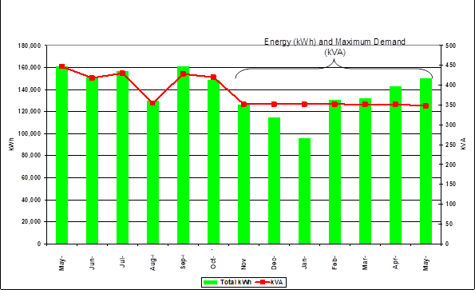

Load Profiles
The metering results from the energy audit should be summarised to illustrate how and where energy is utilized at the site/s.

Figure 3: Electricity Utilization of Site (kWh) [Example]

Other ; 9%
Lighting ; 18%

Office Equipment; 29%

HVAC; 36%
Hot Water; 8%

Energy Audit Summary
The section should provide a concise summary, (e.g. Table 2). The table below provides a guideline of what could be presented and should be expanded or adjusted as deemed necessary.
Table 2: Energy Audit Summary

Number of operating days per Year
Average weekday max consumption (kWh)
Average weekend max consumption (kWh)
Site annual energy use (kWh/a)
Maximum demand (kVA) -weekday
Maximum demand (kVA) -weekend
Baseline energy intensity (kWh/m2/a)
Metering
Tariff type (e.g. small business rate)
Billing authority
Annual energy cost (ZAR/a)
Average electricity price (ZAR/kWh) (year)

REVIEW OF TECHNOLOGY CHOICES

Energy Efficient Technology
This section should provide a motivation and summary for the recommended energy efficiency/ demand side management interventions.
    - Technology 1
In line with the energy audit and the derived consumption baseline, [efficient lighting] (add/remove as required) has been identified as a financially viable intervention. A short explanation of the benefits of the technology is provided in

Figure 4 with the technical information in Table 3 - existing fittings, proposed fittings and the estimated savings.
Figure 4: Benefits of energy efficiency improvements (Lighting) EXAMPLE ONLY
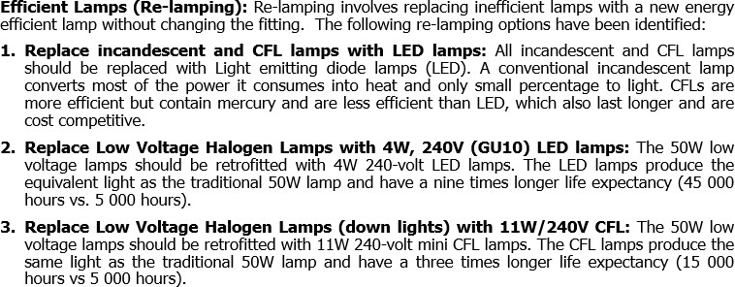

Table 3: Summary of existing and proposed technology attributes (lighting) EXAMPLE

Replacement of inefficient lamps |  |  | Expected Savings |  | Cost
Qty | Existing | Proposed | kW | Annual kWh | Capital | Installation | O&M | Total
325 | 36W T8 | 25W LED
etc

    - Technology 2…. etc

Post-Implementation Annual Consumption
The information from Section 3.1 has been consolidated to calculate the estimated financial benefits. The information should be derived from the energy audit and relevant sections should be attached as an annex and clearly referenced to ensure the reader can find the information with the required level of detail. Any figures used in the calculations, such as electricity tariff and grid emission factor, should be provided with source references and the author must ensure there is alignment with previous sections i.e consistency with tariffs used in previous sections. Metrics used can be added or left out based on the technology.

Table 4: Technical statistics of proposed project intervention EXAMPLE

Description | Technology 1 (Lighting) | Technology 2 (HVAC) | Technology 3 (Solar Panels) | Total
Baseline consumption (kWh/a)
Energy savings (kWh/a)
Energy savings (pre vs post)(%)
1st year cost savings (ZAR/a)
Annual CO2 savings (tCO2/a)
Capital investment (ZAR)

The expected post-implementation energy consumption of the facility is presented in Table 5. A reference (best practise) case has been included to benchmark the project. This should be broken down per individual building when multiple buildings are included.
Table 5: Benchmarking of Energy Consumption

Parameter | Facility Baseline | Facility Post Implementation | CIBSE / EPC  Reference/Benchmark (if applicable)
Energy Usage (kWh/a)
Energy Intensity (kWh/m²/a)
CIBSE Chartered Institute of Building Services Engineers

Monitoring and Evaluation
Monitoring and Evaluation includes the Measurement and Verification (M&V) of energy savings and should also capture key data related to the development and implementation of the project, including capital costs, financing costs, public and private sector investments, maintenance costs, in addition to critical socio-economic data, for example job creation and local economic development.
This section builds on the metering and billing information provided in Section 2.2. Details of how energy usage and billing data is to be collected, stored and analysed to accurately measure the performance of the project investment should be provided. This could include the installation of smart meters, online energy data management systems etc.

FINANCIAL ANALYSIS AND MODELLING
The financial feasibility of each intervention is presented with a 10-year Internal Rate of Return (IRR) and Net Present Value (NPV) {amend as required} calculation based on the following costs and values - Table 6. {Values and assumptions used

for the calculations must be disclosed with reasons as to why they are appropriate}. The results are presented in Table 7.
Table 6: Input values for financial analysis

Description | EE Technologies / Interventions | Notes
Equipment and labour
- Technology 1
- Technology 2
- ……..
Engineering fees
Metering cost
Finance changes
M&V Fees
Annual maintenance / servicing and repairs
Equipment replacement
Annual Tariff increases

Table 7: Project feasibility indicators (per intervention)

Performance Indicator | Value
Investment cost (ZAR)
Expected electricity saving (kWh/a)
Current electricity cost (ZAR/kWh)
Estimated annual tariff increase (%)
Expected electricity savings (kWh/a)
Operational cost savings
Cost, timing and replacement cycle of proposed technology
Percentage of maintenance cost (year 0 to 10)
IRR (10 years)
NPV (10 years)
Dynamic payback period (years)
Recommendation (Proceed/Do not proceed) – if proceed provide requirement (schedule of technology, quantities, minimum performance requirements etc as an Annexure)

Based on the above analysis the following finance model(s) is / are deemed most appropriate (with reasons).
An options analysis of suitable project financing models (internal funding, loans, energy performance contracting, or combination thereof etc) with an analysis of

the advantages and disadvantages of each, concluding with a recommendation for a preferred approach supported with reasoning.

RISK ANALYSIS
The following project risks have been identified and ranked.

A risk matrix ranking probability and impact from low, medium and high should be used. Mitigation strategies or approaches for each one is required. The risk analysis should consider financing approaches and the legislative framework governing public sector financing regulations and the conditions / requirements they place on government institutions.
The first table quantifies the risk according to probability and impact, and the second table identifies the risk and the actions taken to address it. This approach serves as a guideline and should be modified as required.
IMPACT
PROBABILITY

 | LOW | MEDIUM | HIGH
HIGH |  | 4
MEDIUM |  |  | 5
LOW | 3; 6 |  | 1; 2

 | Item | Mitigation measure
1 | Reliable baseline / base data | One years of bills reviewed, and measurement  meters installed for independent reading
2 | Operation & maintenance | Contract includes O&M contract
3 | Product performance and guarantees | Incorporated into EPC contract
4 | Estimated cash flows not generated | Regular staff training on usage; & quarterly  Reporting
5 | Budget for replacement costs | Incorporated in annual budget planning
6 | Accurate and reliable M&V | Independent metering by service provider
 | List others

INSTITUTIONAL REQUIREMENTS
An analysis of the capacity within the [Public Institutions] in relation to the skills required of designing, procurement, contracting, implementation and operation and maintenance is required. The key departments that are key to the successful implementation of any intervention(s) in the Public Institution are engineering,

financial, technical, supply chain, and legal. Approaches of building capacity within these departments where the skills gaps are required. The section should also make recommendations on a preferred methodology to be used by the transactional advisors to assist with capacity building within the Public Institutions
i.e. nominated officials from the Public Institutions can shadow transactional advisors on every aspect of the project. An organogram to identify the roles of different departments, process ownership and their responsibility in relation to contracting and data provision should be included.

ECONOMIC DEVELOPMENT IMPACTS
The section details how the project intervention will positively impact the [Public Institution] and the local economy.

Financial Impacts
This financial impact of the selected interventions will deliver a positive cash flow that will be derived in Year ? as shown in Table 8 and Figure 4
Table 8: EEPBIP Public Sector Cash Flow (ZAR)

Years | 1 | 2 | 3 | …. | 10
Cash Flow
(ZAR)

Figure 4: Project cash flow stream
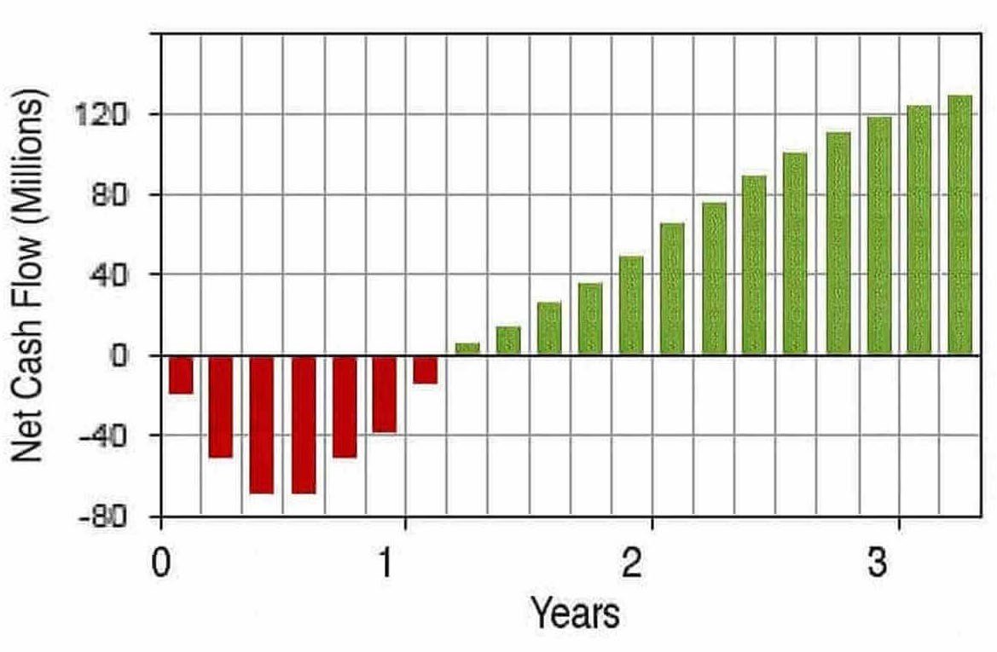

Potential for Job Creation
The following job benefits, where the local economy is prioritised, are expected during construction, implementation, and operations (Table 10)
Table 10: Potential jobs due to project interventions Lighting retrofit - EXAMPLE

Energy Efficiency and Demand Side Management |  | Example of calculation
Assumptions:
Investment |  | R 8 175 331.00
Jobs per Investment Amount, saving trust report (ECEEE summer study proceedings, 2015) |  | 1.4 m euro invested = 32.6  jobs
Euro - Rand Exchange Rate |  | R20.29
Total jobs |  | (1.4m/32.6=42 944 Euro  per job)  (42 944 Euro*R20,29=  871 349 Rand per job)  (R 8 175 331/R 871 349 = 9  jobs)

Local Empowerment, Local Economic Development and Local Content
The section should provide detailed information about the empowerment especially of locals where the intervention will be implemented, and contributions to local content objectives. This empowerment objectives can be hardwired in the procurement document in relation to the procurement regulations by making subcontracting a prequalifying criterion. Care must be taken to align with local capacity and capability to ensure procurement conditions are realistic and achievable, such that they do not create extensive delays, add costs, or prevent implementation of the project. Concerns identified should be included in the risk matrix.

RECOMMENDATIONS AND WAYFORWARD
Based on the information presented in preceding sections, this section should provide a concise proposed way forward in relation to the implementation of planned intervention(s) and the requirement for appointment of transactional advisors and the period. It should summaries some of the key data substantiating why the intervention(s) makes business and developmental sense to [xx municipality] and should be considered for funding and implementation. The following information (minimum) should be included:
- Estimated annual energy savings
- Estimated annual financial savings
- Estimated annual carbon emissions reduction
- Direct and indirect jobs (during and post implementation)
- Contribution to local economic development
- Support to the growth of ESCOs
- Skills transfer

9.1 2027/28 FY GRANT/PRIVATE FINANCE LEVERAGE RATIO

No | Project | Project Description | Qty | Grant Required | Private Finance
1 | ESPC Business Case Development | Energy Audits, Confirmation of Baseline and Financial Modeling for energy performance improvement of 50 buildings | 1 | R 700 000 | R 500 000
2 | Smart metering and building energy management system | Establishment of monitoring and energy management system | 100 | R 2 000 000 | R 1 000 000
3 | Retrofitting of Building Lights | 36 W T8 with LEDs | 325 | R 100 000 | R 2 600 000
4 | Retrofitting of HVAC system | Various Split HVAC system | 50 | R 800 000 | R 1 500 000
5 | Etc
Total |  |  |  | R 3 600 000 | R 5 600 000

9.2 2028/29 FY GRANT/PRIVATE FINANCE LEVERAGE RATIO

No | Project | Project Description | Qty | Grant Required | Private Finance
1 | ESPC Business Case Development for Public Lighting | Energy Audits, Confirmation of Baseline and Financial Modeling for energy performance improvement of 5000 public lights | 1 | R 700 000 | R 700 000
2 | Retrofitting of high mast lights | 2000 x 1000W HPS to 400 W LED | 2000 | R 1 000 000 | R 4 500 000
3
4
Total |  |  |  | R 1 700 000 | R 5 200 000

9.3 2029/30FY GRANT/PRIVATE FINANCE LEVERAGE RATIO

No | Project | Project Description | Qty | Grant Required | Private Finance
1 | Retrofitting of public slighting | 125 W MV to 30W LED | 2500 | R 500 000 | R 2 600 000
2
3
4
Total |  |  |  | R 500 000 | R 2 600 000

